**DAILY ONLINE ACTIVITIES SUMMARY**

|  |  |  |  |  |  |  |  |  |
| --- | --- | --- | --- | --- | --- | --- | --- | --- |
| **Date:** | **24/05/2020** | | | | | **Name:** | **Manish B Shriyan** | |
| **Sem & Sec** | **8th sem B sec** | | | | | **USN:** | **4AL16CS131** | |
| **Online Test Summary** | | | | | | | | |
| **Subject** | | **---** | | | | | | |
| **Max. Marks** | | **--** | | **Score** | | | **--** | |
| **Certification Course Summary** | | | | | | | | |
| **Course** | **Machine Learning Onramp** | | | | | | | |
| **Certificate Provider** | | | **MathWorks** | | **Duration** | | | **3 Hours** |
| **Coding Challenges** | | | | | | | | |
| **Problem Statement:**  **Python program to find smallest number in a list** | | | | | | | | |
| **Status: Solved** | | | | | | | | |
| **Uploaded the report in Github** | | | | | **Uploaded** | | | |
| **If yes Repository name** | | | | | **ManishShriyan** | | | |
| **Uploaded the report in slack** | | | | | **Yes** | | | |

Online Test Details:

No test conducted

Certification Course Details:

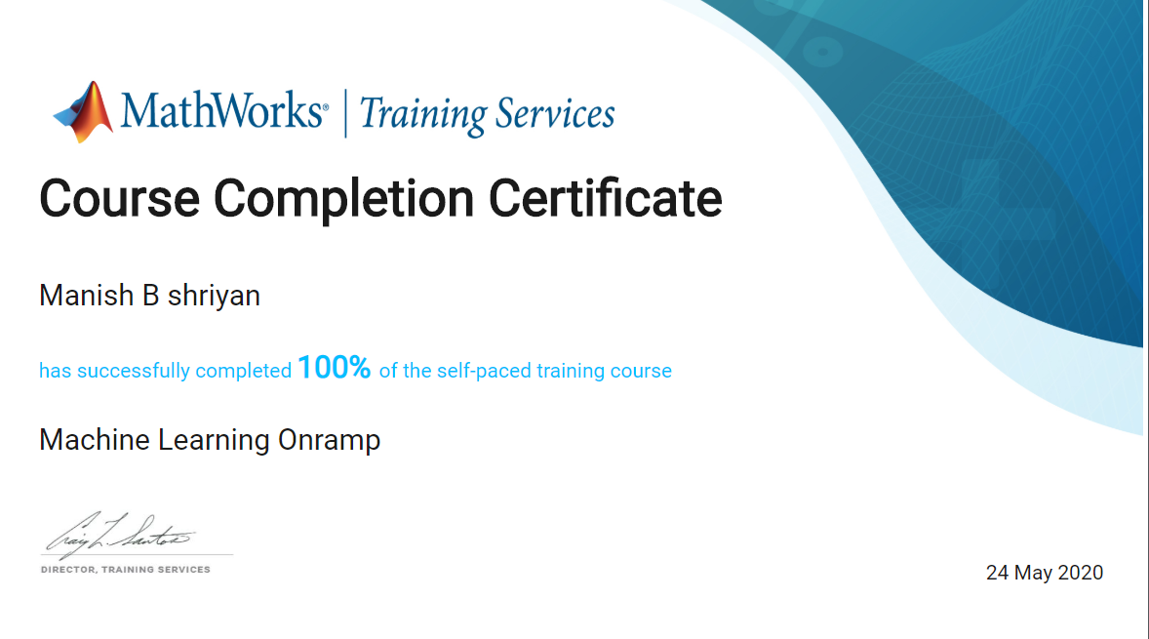

Coding Challenges Details:

# Python program to find smallest

# number in a list

# creating empty list

list1 = []

# asking number of elements to put in list

num = int(input("Enter number of elements in list: "))

# iterating till num to append elements in list

for i in range(1, num + 1):

    ele= int(input("Enter elements: "))

    list1.append(ele)

# print maximum element

print("Smallest element is:", min(list1))